**HW3**

**Name:** Guan Yue Wang

**URL:** <https://web6.jhuep.com/~gwang39/HW3gwang.html>

**The screen shot of HTML validation**

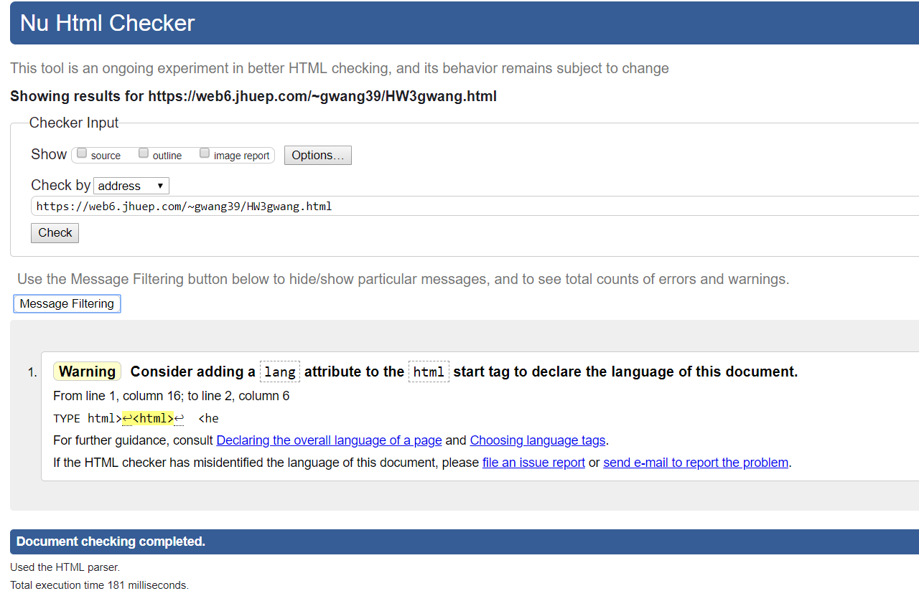

**The zip of the Java source and class files**: see attached file for the program package

**The main class name of Java application:** Hw3calculator

**Screen shot of your Java program:**

* Positive Result

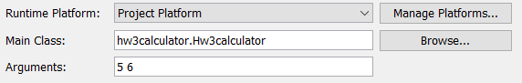

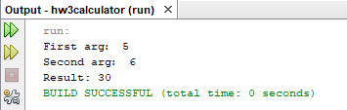

* Negative Result

